**Unit 9: Exponential**

**Lesson 4: Writing Equations from tables & Graphs**

**Objectives:**

* I understanding the different banking investment options
* I can evaluate the amount of money generated from using different investment options
* I can identify linear, exponential and quadratic functions examining tables of data.
* I can write a linear, quadratic and exponential function examining a table of data.

**Agenda:**

* Quiz on lesson 1 and lesson 2
* Class Discovery
  + Linear vs. Exponential vs. Quadratic tables
* Using the calculator to write equations
* Practice

**Focus Questions:**

* How can identify the nature of a function examining data in a table?
* How can I use the calculator to write my functions?

**Homework: HW 9-4**

Do Now:

1. If you have $4𝟎𝟎0 to invest for 20 years, would you rather invest your money in a bank that pays 7.5% simple interest or 5.5% interest compounded annually?

${A=P(1+\frac{r}{n})}^{n.t}$ $A=P\left(1+rt\right)$

**2)** The population of Springfield is 14,530 people and is increasing by 4.5% each year.

1. Write a function representing the population after x years.
2. If this growth rate continues, what will the population be in 17 years?

3)Lena’s car cost $32,400 new. Each year the value decreases by 12.5%.

1. Write a function representing the value of the car after x years.
2. Use your equation to determine the car’s value when it is 10 years old TO THE NEAREST DOLLAR.

**Notes:** **Write a function that accurately represent each table.**

|  |  |
| --- | --- |
| *x* | *y* |
| 0 | 1 |
| 1 | 2 |
| 2 | 4 |
| 3 | 8 |
| 4 | 16 |

|  |  |
| --- | --- |
| *x* | *y* |
| -1 | 6 |
| 0 | 3 |
| 1 | 2 |
| 2 | 3 |
| 3 | 6 |
| 4 | 11 |

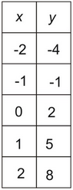 Table I Table II Table III

|  |  |  |
| --- | --- | --- |
| http://mathbits.com/MathBits/StudentResources/GraphPaper/10x10.gif | http://mathbits.com/MathBits/StudentResources/GraphPaper/10x10.gif | http://mathbits.com/MathBits/StudentResources/GraphPaper/10x10.gif |

Graph the above functions from the given tables and identify the type of function:

**Using the calculator to identify functions:** For each Table do the following:

1. Go to 2nd , Catalog
2. Alpha $x^{-1}$
3. Choose **Diagnostic On** from the list
4. Hit **Enter** twice
5. Hit the **STAT** key on your calculator.
6. Go to **1: EDIT**
7. In **L1**, enter all the x values in the table.
8. In **L2**, enter all the y values in the table.
9. Hit the **STAT** key again.
10. Go to **CALC** If you have
11. Linear function go to **4:LinReg(ax+b)**
12. Quadratic function go to **5:QuadReg**
13. Exponential function go to **0:ExpReg**
14. Find the value of r (this value tells you which regression better represent the data)

$$-1≤r≤1$$

The closer the value to 1 and -1 the better the regression.

|  |  |  |
| --- | --- | --- |
| Function for table 1 | Function for table 2 | Function for table 3 |

**Round 2: Given the following tables:**

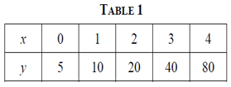 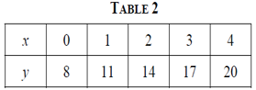

Equation : ________________ Equation: __________________

Type: _______________ Type: ____________________

1. Calculate the rate of change for each function over the interval $1≤x≤3$
2. Which function has a greater rate of change.

**Round 3:**

Write a function that appropriately represents each graph.

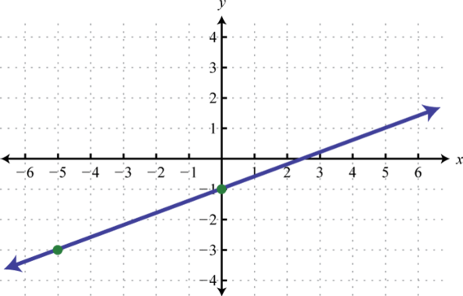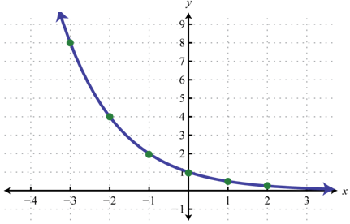

**Name: __________Exponential functions Homework 9-4:**

1. Look at the following tables: Identify if the function is linear, exponential or quadratic and **write its function.**

|  |  |  |  |  |  |  |  |  |  |  |  |  |  |  |  |  |  |  |
| --- | --- | --- | --- | --- | --- | --- | --- | --- | --- | --- | --- | --- | --- | --- | --- | --- | --- | --- |
| |  |  | | --- | --- | | **x** | **y** | | **-3** | **14** | | **-2** | **4** | | **-1** | **-2** | | **0** | **-4** | | **1** | **-2** | | **2** | **4** | | **3** | **14** | |  |  |

1. Find the average rate of change (slope) over the interval -3 ≤ x ≤ 0 for these functions then put them from least to greatest.

|  |  |
| --- | --- |
| x | y |
| -3 | 5 |
| -2 | 10 |
| -1 | 15 |
| 0 | 20 |

1. 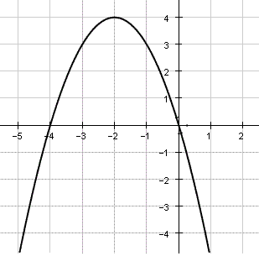 b. c. $f\left(x\right)=2^{-x}$

Extra Problems

1. Krystal was given $3000 when she turned 2 years old. Her parents invested it at a 2% interest rate compounded annually. No deposits or withdrawals were made. Which expression can be used to determine how much money Krystal had in the account when she turned 18?

(1) $3000{(1+0.02)}^{16}$ (3) $3000{(1+0.02)}^{18}$

(2) $3000{(1-0.02)}^{16}$ (4) $3000{(1-0.02)}^{18}$

1. The table below shows the average yearly balance in a savings account where interest is compounded annually. No money is deposited or withdrawn after the initial amount is deposited. Which type of function best models the given data?

(1) linear function with a negative rate of change

(2) linear function with a positive rate of change

(3) exponential decay function

(4) exponential growth function

1. If you have $𝟐𝟎𝟎 to invest for 10 years, would you rather invest your money in a bank that pays 7% simple interest or 5% interest compounded annually?
$${A=P(1+\frac{r}{n})}^{n.t}$$

$$A=P\left(1+rt\right)$$

2. 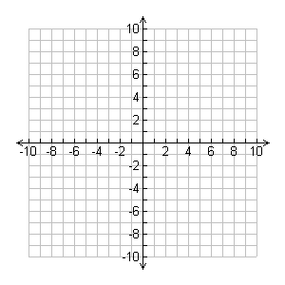Graph the following exponential function:

$f\left(x\right)=2{(\frac{1}{2})}^{x}$ On the interval $-2≤x≤2$.

1. What is an appropriate range?

b. Determine whether this function is Growth or decay? Why ?

* 1. What is the initial value for this function when x=0?

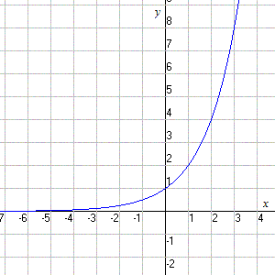

1. If $f\left(x\right)=3^{x}$ and $g\left(x\right)=2x+5$, at which value of x is $f\left(x\right)<g(x)$?
2. -1 (3) -3
3. 2 (4) 4

1. Look at the following function and identify the following:

$f\left(x\right)=2x+5$ $f\left(x\right)=3{(5)}^{x}$

Name the function; identify the initial value and the rate of change/ Decay or growth factor.

Graph both functions:

Discuss your options:

1. Student Friendly Bank pays a simple interest rate of 2.5% per year. neighborhood Bank pays a compound interest rate of 2.1% per year, compounded monthly. Which bank will provide the largest balance

$${A=P(1+\frac{r}{n})}^{n.t}$$

$$A=P\left(1+rt\right)$$

a. If you plan to invest $𝟏𝟎, 𝟎𝟎𝟎 for 10 years?

b. For 20 years?

c. Estimate when the first option will generate at least $14000?

1. James needs $200 to start a snow cone stand for this hot summer. He borrows the money from a bank that charges 4% simple interest a year.
2. Write down the equation that will help you identify the money earned f(x) after x years?
3. How much will he owe if he waits 1 year to pay back the loan?
4. If he waits two years? 3 years?